**Invasion-mediated changes to habitat subsidies impact recipient intertidal invertebrates and algae**

**Abstract**

Habitat subsidies, such as nutrients, organic particles, and larvae, play a crucial role in shaping recipient ecosystems. Human activities, including species introductions and climate-driven range shifts, are altering the quantity and quality of these subsidies. For example, invasive seaweeds that modify donor ecosystems could change subsidies to recipient rocky shore consumers when seaweeds are dislodged and washed ashore as wrack. However, changes to wrack may have implications on the community beyond the subsidy-dependent consumers. Here, we used lab feeding assays to assess the preference of performance of naïve rocky shore grazers to a novel devilweed and how grazer food choice impacts native benthic seaweeds. We offered Black abalone, Black turban snails, Striped shore crabs, and Blue banded hermit crabs a choice between native kelp and invasive devilweed tissue. Food choice was grazer-specific with some grazers preferring kelp (abalone and turban snails), one grazer preferring devilweed (hermit crabs), and one grazer displaying no preference (shore crabs). Consistent with the Enemy Release Hypothesis, we found that devilweed was underutilized by naïve grazers. Further, we fed a diet of kelp, devilweed, or a mix of both, to Red abalone and turban snails for 43 days. We found that abalone grew less when devilweed was included in their diet, and surprisingly, turban snails grew better on a devilweed diet, indicating that food choice and performance were not necessarily related. Finally, we gave an assemblage of these grazers a cafeteria-style choice of agar-based foods made from Sea lettuce (*Ulva spp.*)*,* brown rockweed (*Silvetia compressa*)*,* and red benthic seaweed (*Centroceras clavulatum*) with either kelp or devilweed. Consisten with the Home-Field Advantage Hypothesis, when offered devilweed, grazing shifted onto familiar native benthic seaweeds, specifically, brown rockweed. Our findings suggest that changes in wrack composition to one that includes devilweed may disproportionally affect some grazers and native seaweeds, in our case, black abalone and *S. compressa*, two organisms that have suffered precipitous declines and low recovery.

**Introduction**

Habitat subsidies can strongly shape the structure and function of recipient ecosystems [(Helfield & Naiman, 2001; Jefferies, 2000; Menge et al., 2003; Nakano et al., 1999; Palumbi, 2003; Polis & Hurd, 1996; Spiller et al., 2010)](https://www.zotero.org/google-docs/?Hh7kxA). Ecological theories (e.g. Enemy Release, Prey Naiveté, and Home-Field Advantage Hypotheses) predict that these novel subsidies will 1) be underutilized by species in naïve recipient ecosystems, 2) suppress performance of naïve species, and 3) shift grazing onto native prey. However, because these subsidies are often detrital and these theories are based on living organisms, it is unclear how these human-mediated changes in subsidies will affect naïve recipient ecosystems. Further, traits related to consumer preference and performance may be very different for such novel subsidies. Thus, we need experiments that examine the consequences of human-mediated alterations of donor ecosystems.

Ecosystems are connected through fluxes of nutrients, organic particles, and larvae from donor systems that can alter species abundances and interactions in recipient food webs [(Gratton et al., 2008; Greig et al., 2012; Nakano et al., 1999; Polis & Hurd, 1996)](https://www.zotero.org/google-docs/?a6cBxR). Subsequently, these subsidies can modify the rates of ecological processes such as competition and predation [(Greig et al., 2012; Palumbi, 2003)](https://www.zotero.org/google-docs/?3WSSY9), and generate trophic cascades [(Jefferies, 2000; Nakano et al., 1999; Polis et al., 1997; Polis & Hurd, 1996)](https://www.zotero.org/google-docs/?UjrEdf). Moreover, climate models predict increasing climatic variability due to anthropogenic global warming [(Yang et al., 2008)](https://www.zotero.org/google-docs/?Ejc0XV), resulting in changes in the composition of donor ecosystems via range shifts and species introductions [(Rilov & Crooks, 2009; Ruiz et al., 1997)](https://www.zotero.org/google-docs/?HVLRMU). Thus, changes in donor communities are likely to have direct impacts on subsidy dependent ecosystems.

Subsidies vary in frequency, magnitude, and quality, leading to variation in their relative importance across trophic levels and habitats [(Marcarelli et al., 2011; Riggi & Bommarco, 2019; Yang et al., 2010)](https://www.zotero.org/google-docs/?KDlaKP). Studies that focus on the quantity of subsidies often ascribe importance to large fluxes of biomass transfers between ecosystems [(Marcarelli et al., 2011)](https://www.zotero.org/google-docs/?1ZaxLd). As such, climatic and environmental events (El Nino events, hurricanes, post-fire erosion) are often drivers of resource pulses and directly change the frequency and magnitude of subsidies [(Yang et al., 2008)](https://www.zotero.org/google-docs/?0lxdzr). Moreover, the quality of the subsidy is essentially dependent on the chemical characteristics of the resource (i.e., caloric, nutrient, and lipid content, stoichiometry, and other measures of chemical characteristics) but depends on emergent properties related to animal needs such as feeding behavior and palatability [(Marcarelli et al., 2011; Yang et al., 2010)](https://www.zotero.org/google-docs/?dOCB45). Thus, quantity and quality of subsidies can affect consumers at an individual level by changing grazing behavior of consumers, numerical response at a population level if consumers utilize the resource, and at the community level by shifting competitive balance [(Yang et al., 2008)](https://www.zotero.org/google-docs/?qiUR7H).

Marine herbivores can play a critical role in the distribution, abundance, and composition of assemblages of seaweeds [(Cacabelos et al., 2010; Wessels et al., 2006)](https://www.zotero.org/google-docs/?UL5JXL). Approximately 68 % of marine benthic primary production is consumed by grazers globally [(Poore et al., 2012)](https://www.zotero.org/google-docs/?vFTqOf). Thus, native grazers are not only an important factor in regulating invasions by seaweeds [(Cacabelos et al., 2010; Parker & Hay, 2005; Strong et al., 2009)](https://www.zotero.org/google-docs/?5Zvvll), they may play a key role in the utilization and remineralization of seaweed subsidies to the coast. However, palatability of novel seaweeds by naïve grazers is species-specific. For example, rocky shore grazers (*Lottorina littorea* and *Psammechinus miliaris*) in the North Sea preferred to eat *Sargassum muticum* from a sympatric population over *S. muticum* from an allopatric Japanese population (Schwartz et al. 2016). Similarly, two rocky shore grazers (*Littorina littorea* and *Aplysia punctata*) in Galicia, Spain, perfered native *Ulva sp.* and *Fucus vesiculosus* over invasive *S. muticum,* while sea urchin *Paracentrotus lividus* fed on all seaweeds indiscriminately [(Cacabelos et al., 2010)](https://www.zotero.org/google-docs/?nH2YGI). Conversely, *Dexamine spinosa* amphipods in North Ireland preferred invasive *M. muticum* over native seaweeds [(Strong et al., 2009)](https://www.zotero.org/google-docs/?sdNSZR). As such, the quality of beached wrack can be determined by whether or not it is consumed by native grazers in subsidized communities.

Wrack subsidies provide important resources to nearshore and shore habitats [(Bustamante et al., 1995; Duggins et al., 1989; Orr et al., 2005)](https://www.zotero.org/google-docs/?7PGF8N). For example, wrack on Bahamian Island coastlines temporarily shift predator behavior [(Kenny et al., 2017)](https://www.zotero.org/google-docs/?FJqtWD), increase predator densities [(Piovia-Scott et al., 2019)](https://www.zotero.org/google-docs/?Bs3Qnu), and ultimately result in a herbivore-mediated trophic cascade on some plants \[(Piovia-Scott et al., 2019)](https://www.zotero.org/google-docs/?fgqyE3). Human-mediated changes to the abundance and composition of seagrasses and seaweeds before they wash ashore could have profound implications on their use by recipient shoreline ecosystems, but these impacts are largely unknown. The naiveté of these ecosystems to these subsidies suggests their use may be different than familiar subsidies.

This is especially important when recipient communities include sensitive and endangered species that rely on wrack. The recent invasion by Devilweed*,* in kelp forests, may pose consequences for recovery of the endangered black abalone*.* Although black abalone are federally protected, their recovery has been slow since various species of abalone suffered precipitous declines due to overharvesting and disease [(Stierhoff et al., 2012)](https://www.zotero.org/google-docs/?B2eRbT). Although not comparable to historical densities, the California Channel Islands support some populations of black abalone within rocky intertidal habitats. Many rocky shore grazers, including abalone at these sites consume various benthic seaweeds and are subsidized by drift kelp. California Giant kelp is a relatively high preference food for abalone (Leighton and Boolootian 1963) often dominates the wrack composition [(Dugan et al., 2003; Hayes, 1974; Vanblaricom & Kenner, 2020)](https://www.zotero.org/google-docs/?KlVoRw). Many of these donor kelp forests have experienced an increase in abundance of devilweed since it was first detected in 2003 [(L. Marks et al., 2015)](https://www.zotero.org/google-docs/?c9VYVO). A report by Kenner and Tomoleoni (2020) estimated that devilweed density has increased from <1 individual per 20m2 in 2015 to 23.1 in 2019. As such, we expect that wrack composition will increasingly include devilweed as donor kelp forests are invaded. Thus, it is important to understand if native grazers in the naïve community will consume the novel wrack subsidy.

Ecological theory (ERH; [Keane & Crowley, 2002)](https://www.zotero.org/google-docs/?Z6J4qz) supports the hypothesis that the lack of a natural enemy creates an advantage that has allowed devilweed to successfully proliferate in kelp forests. Further, the Home-Field Advantage Hypothesis (HFA; [Gholz et al., 2000)](https://www.zotero.org/google-docs/?8gvHkx) predicts that native grazers are likely specialized in decomposing foods, like native kelp, that they frequently encounter. Thus, we hypothesize that novel subsidies will 1) be underutilized by species in naïve recipient ecosystems, 2) suppress performance of species in naïve recipient ecosystems, and 3) shift grazing onto native prey in naïve recipient ecosystems.

To test these hypotheses, we offered several rocky intertidal grazer species, a choice between native California Giant kelp and invasive devilweed. To test how a diet including devilweed impacts the performance of grazers, we fed snails diets that include devilweed and measured soft tissue growth and righting times. Lastly, we offered an assemblage of grazers foods made from native benthic seaweeds and either kelp or devilweed to determine if replacement of kelp with devilweed shifts grazing onto native seaweeds.

**Methods**

*Study sites and organisms*

Striped shore crabs (*Pachygrapsus crassipes*), Blue banded hermit crabs (*Pagurus samuelis*), and Black turban snails (*Tegula funebralis*)are abundant seaweed grazers and wrack detritivores along rocky shores of southern California and the Channel Islands [(Abbott & Haderlie, 1981; K. Aquilino et al., 2012; Barry & Ehret, 1993)](https://www.zotero.org/google-docs/?mtDNgZ). Additionally, Black abalone were historically important grazers prior to declines related to disease and overharvesting (REF). Although Black abalone densities have started to recover on some of the Channel Islands, densities remain at least an order of magnitude below historic levels (REF). We included all of these species in this in the study as they represent a typical assemblage of rocky intertidal grazers in areas experiencing the invasion of devilweed.

*Surveys*

To determine the relative contribution of devilweed to wrack in this region, we surveyed large wrack piles deposited on beaches at five sites on San Nicolas Island. We started by haphazardly selecting a pile of wrack longer than 1 m, and we measured the dimensions of each devilweed at the surface of the pile and the entire pile. Then, we walked along the beach and recorded these same measurements for at 10-15 wrack piles, along a 50m transect. For each pile, we measured the longest visible lengths and widths of each devilweed individual found on the pile surface. These measurements were used to calculate the area of each devilweed using the equation for an ellipse (*A=πab*), where “a” and “b” are the length and width of the devilweed individual. For a single pile, we then added the area of all devilweed individuals. We also measured the longest length and longest width of the entire pile. These dimensions were used to calculate the pile surface area (i.e. the area visible without moving the piles). I THINK WE INCLUDED HEIGHT TO GET SURFACE AREA OF AN ELLIPSOID???

We divided total devilweed area by visible pile area to estimate the proportion of wrack that consisted of devilweed.

We surveyed grazer densities ed at Sunset Cliffs Natural Park (32.71972° N, -117.25725° W) in August 2019. We recorded all snail and crab grazers found within a 0.50 x 0.50m quadrat that was flipped end over end and parallel to shore (n=10). This procedure was repeated in the low, mid, and high intertidal zones. Although this technique accurately sampled turban snails and hermit crabs, it did not sample mobile shore crabs that avoided quadrats. But because shore crabs were present throughout the site, we used only one shore crab per replicate. We acknowledge that this may overestimate the abundance of shore crabs relative to hermit crabs and turban snails in the field. To determine the number of grazers to add to our experiments so that we would have ecologically realistic densities, we multiplied field densities by the floor area of the plastic containers used in the assay.

*Feeding Choice Assays*

To understand how shifting wrack composition affects feeding preferences of rocky shore grazers, we offered grazers a choice of kelp and devilweed. Kelp was collected as fresh wrack from Ocean Beach (32.75380° N, -117.25284° W) and benthic devilweed was collected by snorkel from the jetty at Mission Bay in San Diego (32.76158° N, -117.24521° W). We transported seaweeds to San Diego State University’s Coastal and Marine Institute Laboratory (CMIL). Separate feeding choice assays were conducted with each of the four grazer species (Shore crabs, Hermit crabs, Turban snails, and Black abalone). Non-abalone animals were collected from Sunset Cliffs Natural Park and transported to CMIL. These grazers were held in flow-through seawater. Black abalone (collected and held under ESA Permit #19571-2R) were held in chilled, recirculating seawater at NOAA Southwest Fisheries Center (La Jolla, California). Prior to the assay, all grazers were fed *Ulva spp.* for three days before starving for two days. This pre-assay period attempted to standardize hunger level and to motivate our grazers to feed. All feeding assays were conducted in June 2019, with the exception of Black abalone (August 2019).

We offered 3 turban snails (n=14), 3 hermit crabs (n=14), or a single shore crab (n=15) a choice of devilweed and kelp in plastic containers (190 x 160 x 110mm). Container walls included six 35mm holes lined with window screen (2mm openings) to improve water exchange. Black abalone were housed individually in 280 x 230 x 180mm mesh-lined (5mm), PVC-framed cages with a Plexiglas floor. We offered grazers an equivalent biomass of devilweedand kelp, and we anchoredthese with binder clips (mean ± SE: 7.48 ± 0.40 g for hermit crabs, 7.48 ± 0.33 g for shore crabs, 6.51 ± 0.32 g for turban snails, 20.66 ± 0.35 g for black abalone). All replicates were paired with no-grazer controls to account for changes in mass unrelated to consumption [(Dolecal & Long, 2013)](https://www.zotero.org/google-docs/?ossMJh). Individual replicates were stopped when ~3/4 of either seaweed was consumed or after 6 days. All remaining seaweed and seaweed fragments were blotted dry and weighed. We adjusted for autogenic growth using the equation Ti (Cf /Ci) – Tf, where Ti and Tf represent the seaweed masses of the experimental treatments and Cf and Ci represent the seaweed masses in control treatments before (i) and after (f) the assay [(Dolecal & Long, 2013; Sotka & Hay, 2002)](https://www.zotero.org/google-docs/?2Mdx8A).

*Performance Assays*

To understand how shifting wrack populations affects the performance of rocky shore grazers, we measured the growth and behavior of two grazer species [turban snails and juvenile red abalone (*Haliotis rufescens*)] fed kelp, devilweed, or an equal mixture of the two. We used red abalone as a proxy for black abalone because of logistical challenges of conducting research with endangered black abalone, including that the limited number of captive individuals that we have access to are mature adults that might grow extremely slowly. This approach is further justified because both abalone species include brown seaweeds as important components oftheirdiets [(Leighton & Boolootian, 1963; Nelson et al., 2002; Winter & Estes, 1992)](https://www.zotero.org/google-docs/?047spG), and both abalone have similar growth rates [(Ault, 2009)](https://www.zotero.org/google-docs/?qJsSTa).

We collected turban snails from Sunset Cliffs Natural Park (Shell length = 6-10mm). We used lab-reared, juvenile Red abalone from a single cohort (May 2017) provided by NOAA Southwest Fisheries. Because juvenile abalone have a greater capacity to grow than adults, we selected individuals 45-60mm in length. All organisms were transported to CMIL and placed in plastic containers (190 x 160 x 110mm) with mesh (2mm) covers as described above. The performance assay began March 5, 2020. At this time, all containers were completely submerged in tanks with 14°C recirculating, aerated water with a pH of 7.75. Due to facility closures because of the COVID-19 pandemic, we transported all organisms to LongLab GarageLab (a temporary recirculating seawater system setup in J. Long’s home garage) on March 19, 2020. The experiment was continued at this location until the termination of the experiment (April 17, 2020). At the GarageLab, water temperature was maintained at 15°C. Because artificial seawater was used at this facility, the pH was more basic (range from 8.4-8.7). We monitored ammonia and ammonium daily during the GarageLab portion and used these data to determine dates of partial water replacements (conducted on March 28 and April 1, 2020; 30% and 80%, respectively).

Grazers were offered one of four diets (kelp*,* devilweed*,* a ~1:1 mixture of kelp: devilweed, or starvation, n=20). Although seaweed biomass was not quantified, we added enough seaweed to prevent grazers from becoming food-limited and we tried to add similar amounts of kelp and devilweed in the mixture treatment. We included the entire thallus (i.e., stipes, blades, and pneumatocysts) to account for tissue-specificity in grazer impacts. We assessed diet-related impacts on performance by calculating the change in dry soft tissue mass of the grazers. Final dry tissue mass was calculated by weighing this tissue after dissecting it from the shell, freezing the tissue at -80°C, and freeze-drying it for 24 hours. To estimate initial dry tissue mass, we subsampled 20 individuals from each grazer species at the start of the experiment and calculated a regression of shell length to dry soft tissue mass. This regression was then used to estimate starting soft tissue biomass, non-lethally, based on initial shell lengths measurements.

In addition to impacts on growth, we assessed how diet impacted defensive behaviors of the abalone. We measured righting times at the start and end of the experiment. Specifically, we measured the amount of time abalone needed to right themselves. Because abalone are extremely vulnerable to predators when their ventral tissues are exposed, such assays have been used to understand how environment might influence interactions with predators [(Baldwin et al., 2007; Lachambre et al., 2017)](https://www.zotero.org/google-docs/?F6oMEO). Righting tests involved placing abalone, dorsal side down, in a 14°C water tank without flowing seawater, and timing how long it took abalone to flip over so that their shell was facing up. These tests were conducted until abalone corrected their orientation or timed out at 4 minutes.

*Native Benthic Seaweed Assay*

To understand if shifts in wrack composition (e.g., from kelp to devilweed) cause intertidal grazers to change consumption of native benthic seaweeds, we offered an assemblage of intertidal grazers a choice of native benthic seaweeds in the presence of either kelp or devilweed. This could occur given that shifts in the wrack composition might change the relative palatability of the wrack and the native benthic seaweeds. We collected all grazers and seaweed from Sunset Cliffs Natural Park and transported them to CMIL. Grazer densities in this assay were determined based on the survey described above (turban snails n=3, hermit crabs n=6, Shore crabs n=1). We offered grazers a choice between foods made from either Sea lettuce (*Ulva spp.*)*,* brown rockweed (*Silvetia compressa*)*,* and red benthic seaweed (*Centroceras clavulatum*),and either devilweed or kelp*.*

Because we were unable to collect all of our seaweeds at the same time and we were concerned about changes to palatability while maintaining seaweeds in our lab, we fed grazers agar-based foods made from freeze-dried, homogenized seaweeds. We note that this process maintains chemical traits while removing morphological traits that may also impact palatability. Following methods adopted from previous studies [(Bolser & Hay, 1996; Dolecal & Long, 2013; Thornber et al., 2008)](https://www.zotero.org/google-docs/?VJX3UW) we mixed homogenized seaweed (5.6% w:v) into a heated agar solution (2.0% w:v). This mixture was poured into polypropylene petri dishes (50 mm) and allowed to cool for ~30 min. Once ready, the agar-foods were blotted dry and weighed before being offered to grazers.

Based on previous experiments showing negligible autogenic growth in agar-based foods and due to tank space limitations, we reduced the number of controls to one control for every two experimental replicates with grazers. We used thermoplastic adhesive to secure the petri dishes containing agar-based foods in random order along the length of 330 x 190 x 108 mm containers with mesh (1mm) covered tops (n=20, and n=10 controls). The grazers were placed on the opposite side of the container and allowed to feed. These assays began simultaneously on November 11, 2019. After ~36 hours, all petri dishes were removed from the replicate, blotted dry, and reweighed. We calculated changes in mass using the autogenic growth formula with the average correction factor from controls.

**Statistical Analyses**

All statistical analyses were conducted using R Studio (V. 1.4.1717). Necessary assumptions were met for statistical analyses and post-hoc tests were conducted as needed. For feeding choice assays, we compared changes in seaweed mass, corrected for autogenic growth, using Paired t-tests for each grazer species.

For the performance assay, we estimated initial dry soft tissue masses using linear regression models. To test the effect of all diet treatments including seaweeds (i.e. all but “starved” treatment) on final dry tissue growth, we analyzed grazer species independently with Analysis of Covariance (ANCOVA). Starvation treatments were included for reference. Initial soft tissue dry mass estimates were included as a covariate. We also used ANCOVA to examine the effects of diet on final abalone righting times. This model used initial righting time as a covariate. The model included the interaction between both factors as well as a residual term to account for variability unrelated to the two predictors.

In the Native Benthic Seaweed Assay, we compared total consumption on all foods between the wrack treatments using a two-sample t-test by adding the consumption of native benthic seaweeds (*S. compressa, C. clavulatum,* and *Ulva spp.*) and wrack species (*M. pyrifera* and *S. horneri*). We used a Linear Mixed-Effects model to investigate the effects of wrack species and native benthic seaweeds on consumption. The model included wrack type (native vs. invasive; i.e. kelp vs. devilweed, respectively) and seaweed species as fixed factors, and their interaction. We also included a random intercept for replicate number to account for non-independence (seaweed choice was not independent within replicates).

**Results**

*Preference*

Grazers displayed species-specific feeding preferences for the two types of wrack (Figure 1). Both Black abalone and turban snails preferred kelp, with ##% and ##% more kelp being consumed than devilweed, respectively (Fig. 1a and 1b, t=4.5053, p<0.001 and t= 5.7152, p<0.001, respectively). Although these grazers preferred kelp, both grazers did consume some devilweed (One sample t-test, t=4.782, p<0.001 and t=2.105, p=0.06, for Black abalone and turban snails, respectively). Shore crabs fed similarly on the two wrack species (Fig. 1c, t=0.0739, p=0.9422). In contrast, hermit crabs consumed ##% more devilweed than kelp (Fig. 1d, t=-3.7593, p=0.002385). Interestingly, hermit crabs seemed to avoid consuming kelp entirely (One sample t-test, t=0.147, p=0.89).

*Performance*

Because the relationship between maximum shell length and dry tissue mass was strong and linear for both turban snails (R2 = 0.89, F(1,18)=148.20, p<0.001)and Red abalone(R2 = 0.89, F(1,18)=160.71, p<0.001)*,* we estimated initial dry tissue mass from initial maximum shell length and included this estimate as a covariate in our growth analysis. After controlling for initial dry tissue mass, wrack diet influenced Red abalone and turban snail growth, but in opposing directions (Fig. 2, F2,54= 3.88, p<0.005, F2,54=3.939, p=0.02; respectively). For Red abalone, replacing kelp wrack with devilweed wrack reduced final dry tissue mass by ##% (Fig. 2a). Further, partially replacing kelp wrack with devilweed also reduced final dry tissue mass, but this effect was weaker than the complete replacement (Fig. 2a). For turban snails, however, partially replacing kelp wrack with devilweed increased final dry tissue mass (Fig. 2B). There was also a trend for turban snail growth to be higher with the complete replacement of kelp by devilweed (Fig. 2B). After controlling for differences in initial righting time, diet did not influence abalone righting time although there was a trend for devilweed diets to increase righting time (Fig. 3, F(2,54)=1.219, p=0.305).

*Native Benthic Seaweed Assay*

Replacing kelp with devilweed did not influence total grazing rates of the assemblage (calculated as the sum of the grazing rates on foods made from native benthic seaweeds and one of the two wrack species) (t=37.829, p=0.215). Total consumption in the “Invasive” devilweed treatment was 5.22 ± 0.20g and consumption in the “Native” kelp treatment was 5.97 ± 0.22 g. After controlling for variability from replicate number, the Linear Mixed Effect Model revealed there was no statistical difference in consumption between native and invasive diet (M= -0.0878, SE = 0.2272, p = 0.6990). However, we found a significant positive effect of *S. compressa* on consumption in the invasive diet compared to the other seaweed species (M = 3.2304, SE = 0.2272, p < 0.001). No significance was found for other seaweed species (p < 0.05; Figure 4).

**Discussion**

Invasive species have become increasingly abundant around the world and their effects on native communities are generally unclear as some decimate ecosystems while others assume similar roles to native counterparts[(Chapman, 2016; Kaplanis et al., 2016; Williams & Smith, 2007)](https://www.zotero.org/google-docs/?rBXVoa). Seaweed introductions have resulted in positive and negative impacts on invaded communities, but few studies have investigated how they impact spatial subsidies between ecosystems and the communities that depend on such subsidies [(MacMillan et al., 2016; Suárez-Jiménez et al., 2017)](https://www.zotero.org/google-docs/?ibn4Ww). Here, we showed through feeding assays that devilweed will likely be underutilized by rocky intertidal wrack grazers, may affect grazer performance, and may result in increased utilization of native benthic seaweeds.

When given a choice between devilweed and kelp, abalone and turban snails preferred kelp while shore crabs had no preference and hermit crabs preferred devilweed. This is consistent with previous studies comparing the palatability of devilweed to native and naturalized non-native congeners (*S. agardhianum* and *S. muticum*, respectively), which resulted in lowest consumption of devilweed by black turban snails and purple urchin, *Strongylocentrotus purpuratus*). However, food preference is not always associated with highest performance. Interestingly, black turban snails grew more on mixed (0.0281 ± 0.0018g) devilweed diets (0.0273 ± 0.00217g) and compared to kelp alone (0.0209 ± 0.0119g). This was not the case for abalone, which grew more on their preferred kelp diet (2.7576 ± 0.1738g) than either devilweed (2.0744 ± 0.1134g) or a mix of both (2.4639 ± 0.1356g). It should be noted that righting times were generally slowest for abalone that were fed devilweed, which may impact other aspects of performance such as predator avoidance or resistance to environmental disturbances. Finally, when snail and crab assemblages were offered a choice between kelp or devilweed along with native benthic seaweeds, overall consumption did not differ, but rather, shifted consumption onto native benthic seaweeds*.*

Studies suggest that mixed diets generally result in higher performance than a monospecific diet (e.g. growth or reproductive output) [(Aquilino et al., 2012; Worm et al., 2006)](https://www.zotero.org/google-docs/?RfkLQE). Benefits of a mixed diet are often attributed to 1) higher overall quality of diet due to nutrient balance and complementarity or 2) dilution of toxins and secondary compounds of any one species in the diet [(Bernays et al., 1994; Hägele & Rowell-Rahier, 1999)](https://www.zotero.org/google-docs/?KhKPVZ). Nutritional values of seaweeds vary spatially and temporally but some studies suggest that Giant kelp generally has lower protein and lipid content and higher carbohydrate content than devilweed (14% protein, <1% lipids, 75% carbohydrates for kelp, 21.96-22.94% protein, 1.38-1.96% glycolipids, 19.93-20.81% carbohydrates [(Biancacci et al., 2022; Hossain et al., 2003)](https://www.zotero.org/google-docs/?SaI1eO)).

Unlike previous studies, we did not see strong benefits of a mixed diet. It remains unknown to us if this is because there is no nutrient complementarity between devilweed and kelp. A meta-analysis of 493 experimental manipulations in 161 studies, revealed that mixed diets did not significantly enhance fitness components beyond the *best* single-species diet and reduced fitness when one of the diet components was a toxic species [(Lefcheck et al., 2013)](https://www.zotero.org/google-docs/?bWJJYJ). Inconsistent with the hypothesis that a mixed diet dilutes toxin effects [(Bernays et al., 1994)](https://www.zotero.org/google-docs/?hNYmoV), in some cases, secondary chemistry may reduce fitness even in a mixed diet. At this time, it is unknown to us if devilweed is chemically defended, however, our experiments showed that mixing it with kelp did not result in higher performance than a single species, and any consumption of it reduced growth and performance of abalone.

Since the HFA hypothesis predicts that grazers would more likely utilize the wrack species they frequently encounter, the replacement of kelp by devilweed may shift consumption onto familiar benthic seaweeds. Rocky shore grazers directly and indirectly affect community dynamics and structure by influencing algal abundance, diversity, and productivity [(Aquilino & Stachowicz, 2012; Rhoades et al., 2018; Sousa, 1984)](https://www.zotero.org/google-docs/?V5oRCO). As such, a shift onto habitat-forming species like *S. compressa* [(Graham et al., 2018; Sapper & Murray, 2003; Whitaker et al., 2010)](https://www.zotero.org/google-docs/?dSXHa7) may have community level impacts beyond reduction in biomass from consumption. For example, *S. compressa* understories are inhabited by diverse algae, sessile and mobile invertebrate communities that are protected from desiccation during tidal emersion [(Sapper & Murray, 2003)](https://www.zotero.org/google-docs/?hGS5xC). Moreover, it is anticipated that future climatic events will lead to changes in abundance and distribution of brown seaweeds may be replaced with turf-forming red algae [(Graham et al., 2018)](https://www.zotero.org/google-docs/?CEyvz8), likely leading to further declines of *S. compressa* and species that rely on it.

While various examples exist of nonnative species contributing to biodiversity [(Chapman, 2016)](https://www.zotero.org/google-docs/?QiLLjC), there are very few examples of invasive species positively changing subsidies [(MacMillan et al., 2016; Quijón et al., 2017)](https://www.zotero.org/google-docs/?KlCVLR). In examples where invasive species become part of a subsidy, like *Undaria pinnatifida* in wrack, palatability of the novel species tends to be lower than native  species [(Suárez-Jiménez et al., 2017)](https://www.zotero.org/google-docs/?GOL38h). In such case, higher nutritional value of *U. pinnatifida*, did not make it more palatable to naïve amphipods which may not have preferred it due to its structural toughness compared to native seaweeds. Given no choice, amphipods consumed the invasive, suggesting that it may be eaten alongside native species, even if not preferred [(Suárez-Jiménez et al., 2017)](https://www.zotero.org/google-docs/?Sf0mEm).  No-choice feeding assays and experiments using native grazers that have had a longer history with devilweed in invaded areas will help understand long-term impacts of this invasion.

Although a complete replacement of giant kelp is unlikely, devilweed will continue to invade kelp forests, change the composition of wrack, and likely become established in intertidal zones such as the populations found in Todos Santos Bay, Baja California, Mexico [(Cruz-Trejo et al., 2015)](https://www.zotero.org/google-docs/?RuL4YD), San Clemente and San Nicolas Island (Pollard et al., in prep). Devilweed thrives in disturbed habitats and its invasion in southern California is partially attributed to reduction of biomass of native seaweeds during its peak growth and reproduction period [(Cruz-Trejo et al., 2015; Marks et al., 2020; Sullaway & Edwards, 2020)](https://www.zotero.org/google-docs/?AU5QkT). This is of special concern in areas inhabited by recovering black abalone populations. Since black abalone primarily feed on kelp wrack, increased encounters with devilweed could result in reduced food availability for or reduced performance if they do consume it. We highlight the importance of understanding how species introductions affect ecosystems beyond the communities directly invaded, as they may alter spatial subsidies and recipient communities that depend on them.

**Jeremy’s discussion outline**

* Paragraph 1: What we found.
  + Grazer-specific preference (Snails like kelp, crabs don’t care)
  + Grazer-specific growth (abs grow best on kelp, Teg grow best on Sarg, mixed diet effect on abs)
  + Abs right fastest on kelp
  + Replacement does not affect overall consumption
  + Replacement shifts grazing on native benthics, especially Silvetia
* Impacts on grazers: Novel subsidies can lead to diet shifts and/or grazer-specific impacts on grazers
  + Changed diet (from kelp wrack onto native benthics)
  + Righting response
  + Can we talk about a reduction in nutrition/quality for this specific switch?
  + If diet doesn’t change, grazer-specific impacts
    - Abs suffer, Teg benefits?
* Impacts on seaweed assemblage: Novel subsidies can increase grazing pressure on palatable benthic natives
* If Sargassum invasion progresses/intensifies, will this impact intertidal communities?
  + Shifts in competitive balance between tegula and abalone
* Broadening out: Impacts of novel subsidies on recipient communities may depend on relative palatability of subsidies and recipient assemblage
  + In our case, novel subsidy was less palatable than extant (not sure if that’s the right word) subsidy…and perhaps less palatable than benthic natives
* Small note: Like other studies, preference-performance were sometimes related, sometimes not
* Unlike some studies, We saw no evidence of increased performance in mixed diets.
  + Abs: Intermediate performance on mixed diet.
    - Suggests either sargassum presence had an indirect effect or that abs were incorporating Sargassum into diet
  + Abs: Slower righting response on mixed diet and on par with Sarg
  + Teg: Same performance on mixed diet as best diet (Sarg)
    - Suggests Teg was targeting Sarg in mixed diets
* Why did we see no evidence of diet mixing increasing performance
  + What are the scenarios where marine grazers have performed better on mixed diets?
  + Is there any reason why we shouldn’t have expected this for kelp and Sarg?
* What does all of this mean for Abalone conservation?
  + Can we use Leighton and Boolotian to argue that grazing will be shifted onto lower preference algae?
  + There’s the hint in performance data that they will incorporate Sarg into diet and this will lead to a reduction in growth and righting response.

Doomsday scenario? Wrack seems to to be plentiful…bring in the Marks stuff?

Figure Legend

Figure 1

Figure 2

Figure 3

Figure 4

Figure 1

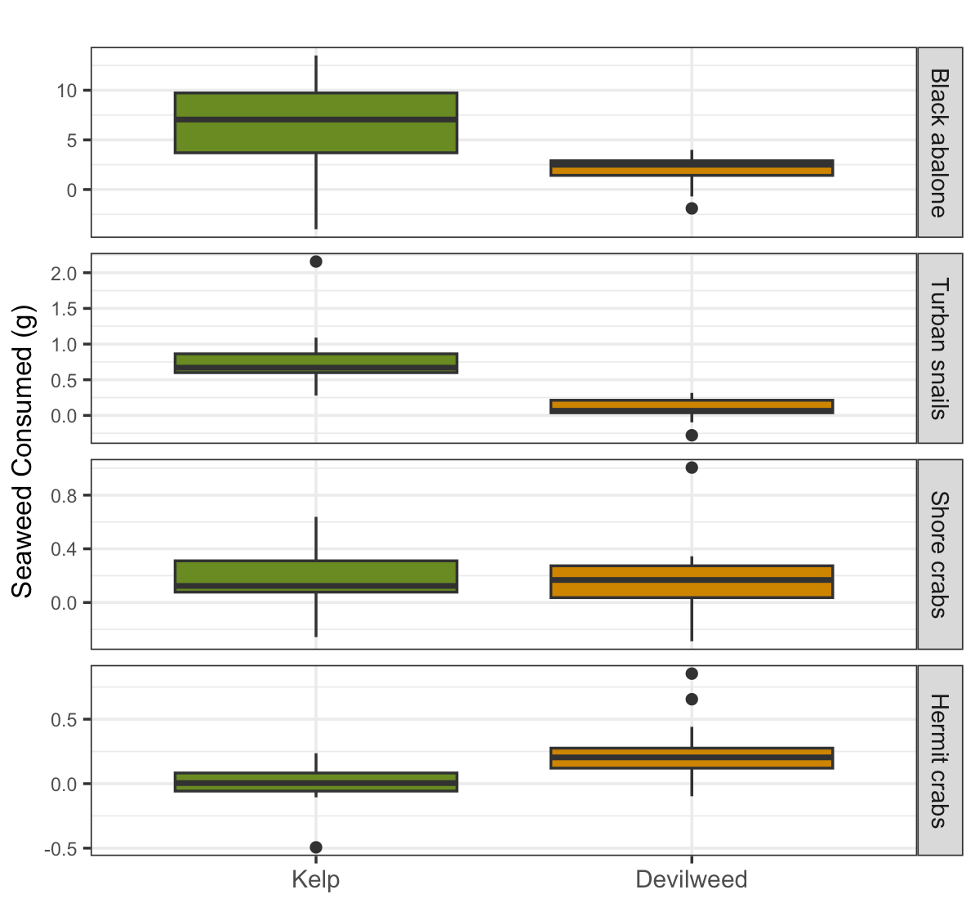

Figure 2

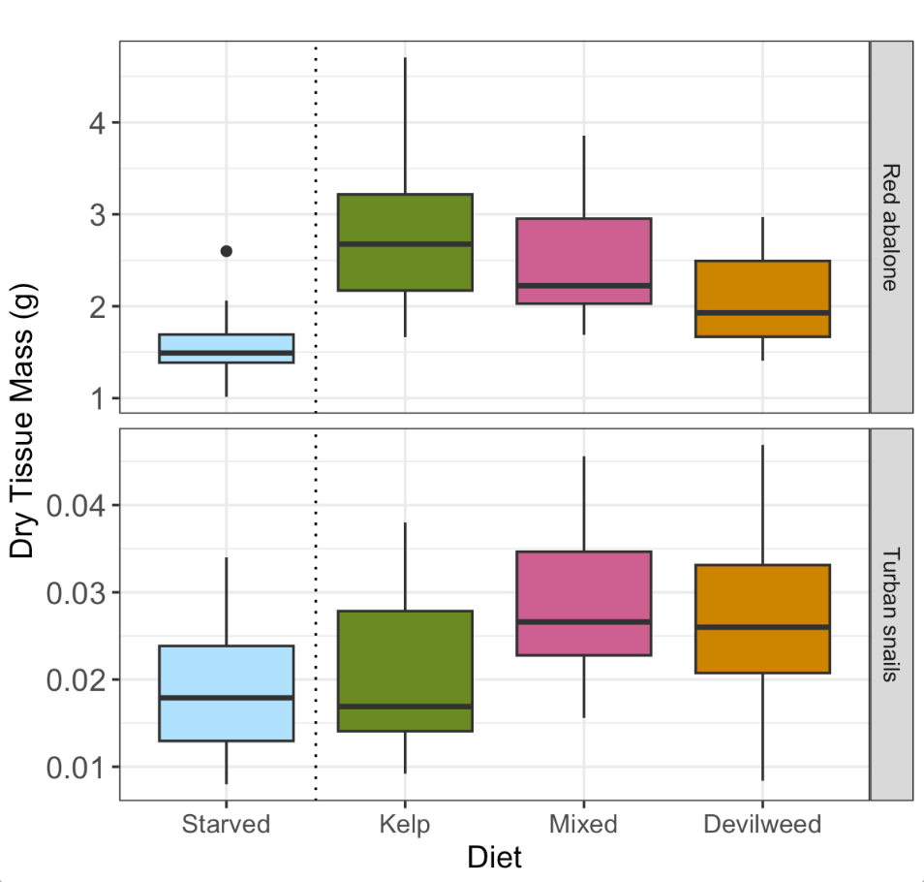

Figure 3

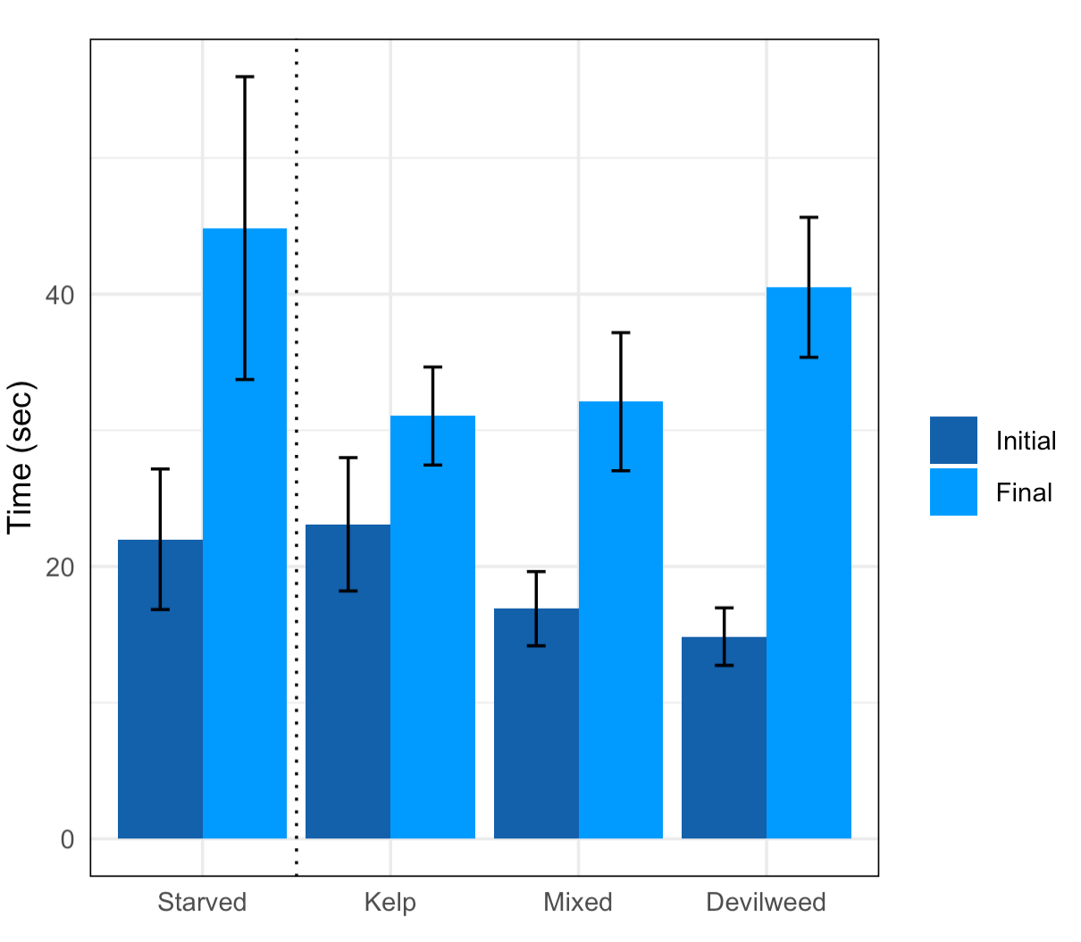

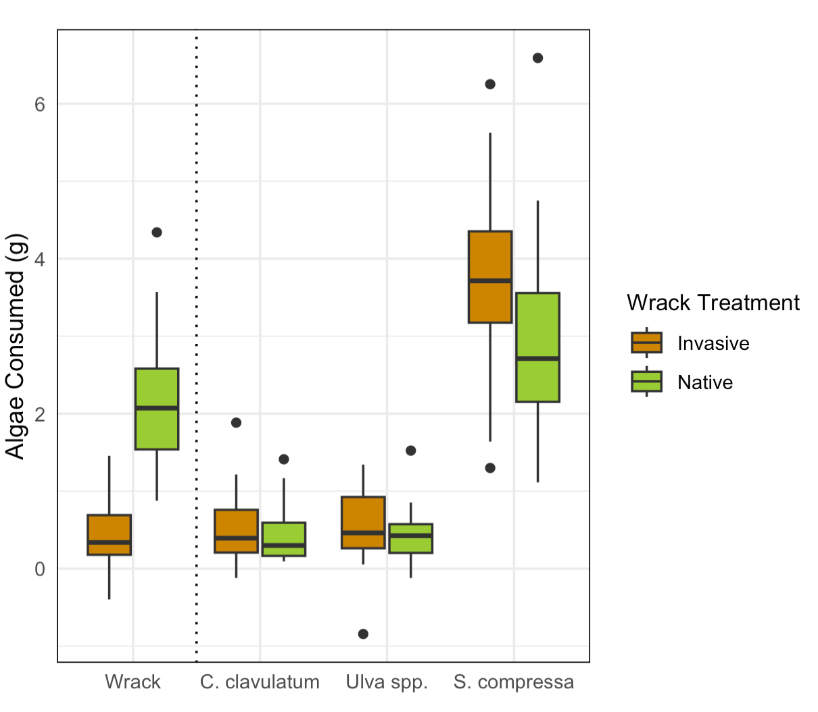

[Abbott, D. P., & Haderlie, E. C. (1981). Intertidal Invertebrates of California. *Systematic Zoology*, *30*(2), 218. https://doi.org/10.2307/2992426](https://www.zotero.org/google-docs/?b8sfoi)

[Aquilino, K., Coulbourne, M., & Stachowicz, J. (2012). Mixed species diets enhance the growth of two rocky intertidal herbivores. *Marine Ecology Progress Series*, *468*, 179–189. https://doi.org/10.3354/meps09893](https://www.zotero.org/google-docs/?b8sfoi)

[Aquilino, K. M., & Stachowicz, J. J. (2012). Seaweed richness and herbivory increase rate of community recovery from disturbance. *Ecology*, *93*(4), 879–890. https://doi.org/10.1890/11-0457.1](https://www.zotero.org/google-docs/?b8sfoi)

[Ault, J. S. (2009). SOME QUANTITATIVE ASPECTS OF REPRODUCTION AND GROWTH OF THE RED ABALONE, Haliotis rufescens SWAINSON. *Journal of the World Mariculture Society*, *16*(1–4), 398–425. https://doi.org/10.1111/j.1749-7345.1985.tb00221.x](https://www.zotero.org/google-docs/?b8sfoi)

[Baldwin, J., Elias, J. P., Wells, R. M. G., & Donovan, D. A. (2007). Energy metabolism in the tropical abalone, Haliotis asinina Linné: Comparisons with temperate abalone species. *Journal of Experimental Marine Biology and Ecology*, *342*(2), 213–225. https://doi.org/10.1016/j.jembe.2006.09.005](https://www.zotero.org/google-docs/?b8sfoi)

[Barry, J. P., & Ehret, M. J. (1993). Diet, food preference, and algal availability for fishes and crabs on intertidal reef communities in southern California. *Environmental Biology of Fishes*, *37*(1), 75–95. https://doi.org/10.1007/BF00000715](https://www.zotero.org/google-docs/?b8sfoi)

[Bernays, E. A., Bright, K. L., Gonzalez, N., & Angel, J. (1994). Dietary Mixing in a Generalist Herbivore: Tests of Two Hypotheses. *Ecology*, *75*(7), 1997–2006. https://doi.org/10.2307/1941604](https://www.zotero.org/google-docs/?b8sfoi)

[Biancacci, C., Sanderson, J. C., Evans, B., Callahan, D. L., Francis, D. S., Skrzypczyk, V. M., Cumming, E. E., & Bellgrove, A. (2022). Variation in biochemical composition of wild-harvested Macrocystis pyrifera (Ochrophyta) from sites proximal and distal to salmon farms in Tasmania, Australia. *Algal Research*, *65*, 102745. https://doi.org/10.1016/j.algal.2022.102745](https://www.zotero.org/google-docs/?b8sfoi)

[Bolser, R. C., & Hay, M. E. (1996). Are Tropical Plants Better Defended? Palatability and Defenses of Temperate vs. Tropical Seaweeds. *Ecology*, *77*(8), 2269–2286. https://doi.org/10.2307/2265730](https://www.zotero.org/google-docs/?b8sfoi)

[Bustamante, R. H., Branch, G. M., Eekhout, S., Robertson, B., Zoutendyk, P., Schleyer, M., Dye, A., Hanekom, N., Keats, D., Jurd, M., & McQuaid, C. (1995). Gradients of intertidal primary productivity around the coast of South Africa and their relationships with consumer biomass. *Oecologia*, *102*(2), 189–201. https://doi.org/10.1007/BF00333251](https://www.zotero.org/google-docs/?b8sfoi)

[Cacabelos, E., Olabarria, C., Incera, M., & Troncoso, J. S. (2010). Do grazers prefer invasive seaweeds? *Journal of Experimental Marine Biology and Ecology*, *393*(1–2), 182–187. https://doi.org/10.1016/j.jembe.2010.07.024](https://www.zotero.org/google-docs/?b8sfoi)

[Chapman, P. M. (2016). Benefits of Invasive Species. *Marine Pollution Bulletin*, *107*(1), 1–2. https://doi.org/10.1016/j.marpolbul.2016.04.067](https://www.zotero.org/google-docs/?b8sfoi)

[Cruz-Trejo, G. I., Ibarra-Obando, S. E., Aguilar-Rosas, L. E., Poumian-Tapia, M., & Solana-Arellano, E. (2015). Presence of Sargassum horneri at Todos Santos Bay, Baja California, Mexico: Its Effects on the Local Macroalgae Community. *American Journal of Plant Sciences*, *06*(17), 2693–2707. https://doi.org/10.4236/ajps.2015.617271](https://www.zotero.org/google-docs/?b8sfoi)

[Dolecal, R. E., & Long, J. D. (2013). Ephemeral macroalgae display spatial variation in relative palatability. *Journal of Experimental Marine Biology and Ecology*, *440*, 233–237. https://doi.org/10.1016/j.jembe.2012.12.009](https://www.zotero.org/google-docs/?b8sfoi)

[Dugan, J. E., Hubbard, D. M., McCrary, M. D., & Pierson, M. O. (2003). The response of macrofauna communities and shorebirds to macrophyte wrack subsidies on exposed sandy beaches of southern California. *Estuarine, Coastal and Shelf Science*, *58*, 25–40. https://doi.org/10.1016/S0272-7714(03)00045-3](https://www.zotero.org/google-docs/?b8sfoi)

[Duggins, D. O., Simenstad, C. A., & Estes, J. A. (1989). Magnification of Secondary Production by Kelp Detritus in Coastal Marine Ecosystems. *Science*, *245*(4914), 170–173. https://doi.org/10.1126/science.245.4914.170](https://www.zotero.org/google-docs/?b8sfoi)

[Gholz, H. L., Wedin, D. A., Smitherman, S. M., Harmon, M. E., & Parton, W. J. (2000). Long-term dynamics of pine and hardwood litter in contrasting environments: Toward a global model of decomposition: LONG-TERM DECOMPOSITION. *Global Change Biology*, *6*(7), 751–765. https://doi.org/10.1046/j.1365-2486.2000.00349.x](https://www.zotero.org/google-docs/?b8sfoi)

[Graham, S., Hong, B., Mutschler, S., Saunders, B., & Bredvik, J. (2018). Changes in Abundance of Silvetia compressa at San Clemente Island before and during the 2015–2016 El Niño. *Western North American Naturalist*, *78*(4), 605. https://doi.org/10.3398/064.078.0405](https://www.zotero.org/google-docs/?b8sfoi)

[Gratton, C., Donaldson, J., & Zanden, M. J. V. (2008). Ecosystem Linkages Between Lakes and the Surrounding Terrestrial Landscape in Northeast Iceland. *Ecosystems*, *11*(5), 764–774. https://doi.org/10.1007/s10021-008-9158-8](https://www.zotero.org/google-docs/?b8sfoi)

[Greig, H. S., Kratina, P., Thompson, P. L., Palen, W. J., Richardson, J. S., & Shurin, J. B. (2012). Warming, eutrophication, and predator loss amplify subsidies between aquatic and terrestrial ecosystems. *Global Change Biology*, *18*(2), 504–514. https://doi.org/10.1111/j.1365-2486.2011.02540.x](https://www.zotero.org/google-docs/?b8sfoi)

[Hägele, B. F., & Rowell-Rahier, M. (1999). Dietary mixing in three generalist herbivores: Nutrient complementation or toxin dilution? *Oecologia*, *119*(4), 521–533. https://doi.org/10.1007/s004420050815](https://www.zotero.org/google-docs/?b8sfoi)

[Hayes, W. B. (1974). Sand-Beach Energetics: Importance of the Isopod Tylos Punctatus. *Ecology*, *55*(4), 838–847. https://doi.org/10.2307/1934419](https://www.zotero.org/google-docs/?b8sfoi)

[Helfield, J. M., & Naiman, R. J. (2001). EFFECTS OF SALMON-DERIVED NITROGEN ON RIPARIAN FOREST GROWTH AND IMPLICATIONS FOR STREAM PRODUCTIVITY. *Ecology*, *82*(9), 2403–2409. https://doi.org/10.1890/0012-9658(2001)082[2403:EOSDNO]2.0.CO;2](https://www.zotero.org/google-docs/?b8sfoi)

[Hossain, Z., . H. K., & . K. T. (2003). Biochemical Composition and Lipid Compositional Properties of the Brown Alga Sargassumhorneri. *Pakistan Journal of Biological Sciences*, *6*(17), 1497–1500. https://doi.org/10.3923/pjbs.2003.1497.1500](https://www.zotero.org/google-docs/?b8sfoi)

[Jefferies, R. L. (2000). *Allochthonous inputs: Integrating population changes and food-web dynamics*. *15*(1), 4.](https://www.zotero.org/google-docs/?b8sfoi)

[Keane, R. (2002). Exotic plant invasions and the enemy release hypothesis. *Trends in Ecology & Evolution*, *17*(4), 164–170. https://doi.org/10.1016/S0169-5347(02)02499-0](https://www.zotero.org/google-docs/?b8sfoi)

[Kenny, H. V., Wright, A. N., Piovia-Scott, J., Yang, L. H., Spiller, D. A., & Schoener, T. W. (2017). Marine subsidies change short-term foraging activity and habitat utilization of terrestrial lizards. *Ecology and Evolution*, *7*(24), 10701–10709. https://doi.org/10.1002/ece3.3560](https://www.zotero.org/google-docs/?b8sfoi)

[Lachambre, S., Day, R., Boudry, P., Huchette, S., Rio-Cabello, A., Fustec, T., & Roussel, S. (2017). Stress response of farmed European abalone reveals rapid domestication process in absence of intentional selection. *Applied Animal Behaviour Science*, *196*, 13–21. https://doi.org/10.1016/j.applanim.2017.07.004](https://www.zotero.org/google-docs/?b8sfoi)

[Lefcheck, J. S., Whalen, M. A., Davenport, T. M., Stone, J. P., & Duffy, J. E. (2013). Physiological effects of diet mixing on consumer fitness: A meta-analysis. *Ecology*, *94*(3), 565–572. https://doi.org/10.1890/12-0192.1](https://www.zotero.org/google-docs/?b8sfoi)

[Leighton, D., & Boolootian, R. A. (1963). *DIET AND GROWTH IN THE BLACK ABALONE, HALJOTIS CRACHERODII*. *44*(2), 13.](https://www.zotero.org/google-docs/?b8sfoi)

[MacMillan, M. R., Tummon Flynn, P., Duarte, C., & Quijón, P. A. (2016). Near-edge wrack effects on bare sediments: Small scale variation matters in the monitoring of sandy beaches. *Marine Environmental Research*, *122*, 196–200. https://doi.org/10.1016/j.marenvres.2016.10.010](https://www.zotero.org/google-docs/?b8sfoi)

[Marcarelli, A. M., Baxter, C. V., Mineau, M. M., & Hall, R. O. (2011). Quantity and quality: Unifying food web and ecosystem perspectives on the role of resource subsidies in freshwaters. *Ecology*, *92*(6), 1215–1225. https://doi.org/10.1890/10-2240.1](https://www.zotero.org/google-docs/?b8sfoi)

[Marks, L. M., Reed, D. C., & Holbrook, S. J. (2020). Niche Complementarity and Resistance to Grazing Promote the Invasion Success of Sargassum horneri in North America. *Diversity*, *12*(2), 54. https://doi.org/10.3390/d12020054](https://www.zotero.org/google-docs/?b8sfoi)

[Marks, L., Salinas-Ruiz, P., Reed, D., Holbrook, S., Culver, C., Engle, J., Kushner, D., Caselle, J., Freiwald, J., Williams, J., Smith, J., Aguilar-Rosas, L., & Kaplanis, N. (2015). Range expansion of a non-native, invasive macroalga Sargassum horneri (Turner) C. Agardh, 1820 in the eastern Pacific. *BioInvasions Records*, *4*(4), 243–248. https://doi.org/10.3391/bir.2015.4.4.02](https://www.zotero.org/google-docs/?b8sfoi)

[Menge, B. A., Lubchenco, J., Bracken, M. E. S., Chan, F., Foley, M. M., Freidenburg, T. L., Gaines, S. D., Hudson, G., Krenz, C., Leslie, H., Menge, D. N. L., Russell, R., & Webster, M. S. (2003). Coastal oceanography sets the pace of rocky intertidal community dynamics. *Proceedings of the National Academy of Sciences*, *100*(21), 12229–12234. https://doi.org/10.1073/pnas.1534875100](https://www.zotero.org/google-docs/?b8sfoi)

[Nakano, S., Miyasaka, H., & Kuhara, N. (1999). TERRESTRIAL–AQUATIC LINKAGES: RIPARIAN ARTHROPOD INPUTS ALTER TROPHIC CASCADES IN A STREAM FOOD WEB. *Ecology*, *80*(7), 2435–2441. https://doi.org/10.1890/0012-9658(1999)080[2435:TALRAI]2.0.CO;2](https://www.zotero.org/google-docs/?b8sfoi)

[Nelson, M. M., Leighton, D. L., Phleger, C. F., & Nichols, P. D. (2002). Comparison of growth and lipid composition in the green abalone, Haliotis fulgens, provided specific macroalgal diets. *Comparative Biochemistry and Physiology Part B: Biochemistry and Molecular Biology*, *131*(4), 695–712. https://doi.org/10.1016/S1096-4959(02)00042-8](https://www.zotero.org/google-docs/?b8sfoi)

[Orr, M., Zimmer, M., Jelinski, D. E., & Mews, M. (2005). WRACK DEPOSITION ON DIFFERENT BEACH TYPES: SPATIAL AND TEMPORAL VARIATION IN THE PATTERN OF SUBSIDY. *Ecology*, *86*(6), 1496–1507. https://doi.org/10.1890/04-1486](https://www.zotero.org/google-docs/?b8sfoi)

[Palumbi, S. R. (2003). Ecological subsidies alter the structure of marine communities. *Proceedings of the National Academy of Sciences*, *100*(21), 11927–11928. https://doi.org/10.1073/pnas.2335832100](https://www.zotero.org/google-docs/?b8sfoi)

[Parker, J. D., & Hay, M. E. (2005). Biotic resistance to plant invasions? Native herbivores prefer non‐native plants. *Ecology Letters*, *8*(9), 959–967. https://doi.org/10.1111/j.1461-0248.2005.00799.x](https://www.zotero.org/google-docs/?b8sfoi)

[Piovia‐Scott, J., Yang, L. H., Wright, A. N., Spiller, D. A., & Schoener, T. W. (2019). Pulsed seaweed subsidies drive sequential shifts in the effects of lizard predators on island food webs. *Ecology Letters*, *22*(11), 1850–1859. https://doi.org/10.1111/ele.13377](https://www.zotero.org/google-docs/?b8sfoi)

[Polis, G. A., Anderson, W. B., & Holt, R. D. (1997). TOWARD AN INTEGRATION OF LANDSCAPE AND FOOD WEB ECOLOGY:The Dynamics of Spatially Subsidized Food Webs. *Annual Review of Ecology and Systematics*, *28*(1), 289–316. https://doi.org/10.1146/annurev.ecolsys.28.1.289](https://www.zotero.org/google-docs/?b8sfoi)

[Polis, G. A., & Hurd, S. D. (1996). Linking Marine and Terrestrial Food Webs: Allochthonous Input from the Ocean Supports High Secondary Productivity on Small Islands and Coastal Land Communities. *The American Naturalist*, *147*(3), 396–423. https://doi.org/10.1086/285858](https://www.zotero.org/google-docs/?b8sfoi)

[Poore, A. G. B., Campbell, A. H., Coleman, R. A., Edgar, G. J., Jormalainen, V., Reynolds, P. L., Sotka, E. E., Stachowicz, J. J., Taylor, R. B., Vanderklift, M. A., & Emmett Duffy, J. (2012). Global patterns in the impact of marine herbivores on benthic primary producers. *Ecology Letters*, *15*(8), 912–922. https://doi.org/10.1111/j.1461-0248.2012.01804.x](https://www.zotero.org/google-docs/?b8sfoi)

[Quijón, P. A., Tummon Flynn, P., & Duarte, C. (2017). Beyond negative perceptions: The role of some marine invasive species as trophic subsidies. *Marine Pollution Bulletin*, *116*(1–2), 538–539. https://doi.org/10.1016/j.marpolbul.2017.01.020](https://www.zotero.org/google-docs/?b8sfoi)

[Rhoades, O. K., Best, R. J., & Stachowicz, J. J. (2018). Assessing Feeding Preferences of a Consumer Guild: Partitioning Variation Among versus Within Species. *The American Naturalist*, *192*(3), 287–300. https://doi.org/10.1086/698325](https://www.zotero.org/google-docs/?b8sfoi)

[Riggi, L. G. A., & Bommarco, R. (2019). Subsidy type and quality determine direction and strength of trophic cascades in arthropod food web in agro‐ecosystems. *Journal of Applied Ecology*, 1365-2664.13444. https://doi.org/10.1111/1365-2664.13444](https://www.zotero.org/google-docs/?b8sfoi)

[Rilov, G., & Crooks, J. A. (Eds.). (2009). *Biological invasions in marine ecosystems: Ecological, management and geographic perspectives*. Springer.](https://www.zotero.org/google-docs/?b8sfoi)

[Ruiz, G. M., Carlton, J. T., Grosholz, E. D., & Hines, A. H. (1997). Global Invasions of Marine and Estuarine Habitats by Non-Indigenous Species: Mechanisms, Extent, and Consequences. *American Zoologist*, *37*(6), 621–632. https://doi.org/10.1093/icb/37.6.621](https://www.zotero.org/google-docs/?b8sfoi)

[Sapper, S. A., & Murray, S. N. (2003). Variation in Structure of the Subcanopy Assemblage Associated with Southern California Populations of the Intertidal Rockweed Silvetia compressa (Fucales). *Pacific Science*, *57*(4), 433–462. https://doi.org/10.1353/psc.2003.0035](https://www.zotero.org/google-docs/?b8sfoi)

[Sotka, E. E., & Hay, M. E. (2002). *GEOGRAPHIC VARIATION AMONG HERBIVORE POPULATIONS IN TOLERANCE FOR A CHEMICALLY RICH SEAWEED*. *83*(10), 15.](https://www.zotero.org/google-docs/?b8sfoi)

[Sousa, W. P. (1984). Intertidal Mosaics: Patch Size, Propagule Availability, and Spatially Variable Patterns of Succession. *Ecology*, *65*(6), 1918–1935. https://doi.org/10.2307/1937789](https://www.zotero.org/google-docs/?b8sfoi)

[Spiller, D. A., Piovia-Scott, J., Wright, A. N., Yang, L. H., Takimoto, G., Schoener, T. W., & Iwata, T. (2010). Marine subsidies have multiple effects on coastal food webs. *Ecology*, *91*(5), 1424–1434. https://doi.org/10.1890/09-0715.1](https://www.zotero.org/google-docs/?b8sfoi)

[Stierhoff, K. L., Neuman, M., & Butler, J. L. (2012). On the road to extinction? Population declines of the endangered white abalone, Haliotis sorenseni. *Biological Conservation*, *152*, 46–52. https://doi.org/10.1016/j.biocon.2012.03.013](https://www.zotero.org/google-docs/?b8sfoi)

[Strong, J. A., Maggs, C. A., & Johnson, M. P. (2009). The extent of grazing release from epiphytism for *Sargassum muticum* (Phaeophyceae) within the invaded range. *Journal of the Marine Biological Association of the United Kingdom*, *89*(2), 303–314. https://doi.org/10.1017/S0025315408003226](https://www.zotero.org/google-docs/?b8sfoi)

[Suárez-Jiménez, R., Hepburn, C. D., Hyndes, G. A., McLeod, R. J., Taylor, R. B., & Hurd, C. L. (2017). Importance of the invasive macroalga Undaria pinnatifida as trophic subsidy for a beach consumer. *Marine Biology*, *164*(5), 113. https://doi.org/10.1007/s00227-017-3140-y](https://www.zotero.org/google-docs/?b8sfoi)

[Sullaway, G., & Edwards, M. (2020). Impacts of the non-native alga Sargassum horneri on benthic community production in a California kelp forest. *Marine Ecology Progress Series*, *637*, 45–57. https://doi.org/10.3354/meps13231](https://www.zotero.org/google-docs/?b8sfoi)

[Thornber, C., Jones, E., & Stachowicz, J. (2008). Differences in herbivore feeding preferences across a vertical rocky intertidal gradient. *Marine Ecology Progress Series*, *363*, 51–62. https://doi.org/10.3354/meps07406](https://www.zotero.org/google-docs/?b8sfoi)

[Vanblaricom, G. R., & Kenner, M. C. (n.d.). *DIETARY PATTERNS IN BLACK ABALONE HALIOTIS CRACHERODII LEACH, 1814 AS INDICATED BY OBSERVATION OF DRIFT ALGAL AND SEAGRASS CAPTURE AT SAN NICOLAS ISLAND, CALIFORNIA, USA, 1982 TO 2019*. 12.](https://www.zotero.org/google-docs/?b8sfoi)

[Wessels, H., Hagen, W., Molis, M., Wiencke, C., & Karsten, U. (2006). Intra- and interspecific differences in palatability of Arctic macroalgae from Kongsfjorden (Spitsbergen) for two benthic sympatric invertebrates. *Journal of Experimental Marine Biology and Ecology*, *329*(1), 20–33. https://doi.org/10.1016/j.jembe.2005.08.006](https://www.zotero.org/google-docs/?b8sfoi)

[Whitaker, S. G., Smith, J. R., & Murray, S. N. (2010). Reestablishment of the Southern California Rocky Intertidal Brown Alga, Silvetia compressa: An Experimental Investigation of Techniques and Abiotic and Biotic Factors That Affect Restoration Success. *Restoration Ecology*, *18*, 18–26. https://doi.org/10.1111/j.1526-100X.2010.00717.x](https://www.zotero.org/google-docs/?b8sfoi)

[Winter, F. C., & Estes, J. A. (1992). Experimental evidence for the effects of polyphenolic compounds from Dictyoneurum californicum Ruprecht (Phaeophyta: Laminariales) on feeding rate and growth in the red abalone Haliotus rufescens Swainson. *Journal of Experimental Marine Biology and Ecology*, *155*(2), 263–277. https://doi.org/10.1016/0022-0981(92)90067-K](https://www.zotero.org/google-docs/?b8sfoi)

[Worm, B., Barbier, E. B., Beaumont, N., Duffy, J. E., Folke, C., Halpern, B. S., Jackson, J. B. C., Lotze, H. K., Micheli, F., Palumbi, S. R., Sala, E., Selkoe, K. A., Stachowicz, J. J., & Watson, R. (2006). Impacts of Biodiversity Loss on Ocean Ecosystem Services. *Science*, *314*(5800), 787–790. https://doi.org/10.1126/science.1132294](https://www.zotero.org/google-docs/?b8sfoi)

[Yang, L. H., Bastow, J. L., Spence, K. O., & Wright, A. N. (2008). WHAT CAN WE LEARN FROM RESOURCE PULSES. *Ecology*, *89*(3), 621–634. https://doi.org/10.1890/07-0175.1](https://www.zotero.org/google-docs/?b8sfoi)

[Yang, L. H., Edwards, K. F., Byrnes, J. E., Bastow, J. L., Wright, A. N., & Spence, K. O. (2010). A meta-analysis of resource pulse–consumer interactions. *Ecological Monographs*, *80*(1), 125–151. https://doi.org/10.1890/08-1996.1](https://www.zotero.org/google-docs/?b8sfoi)